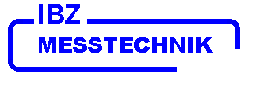

CHIRALYSER - MP

Instruction Manual

Version CHI 7.3x (LED 426 nm)

Table of contents

1.0 Notes and Warnings
  - Function Principle

- Installation
2.1 Electrical connections

- Start of Measurement
3.1 Peak detection

- Change Instrument settings
4.1 RANGE
4.2 AVR (time constant)
4.3 BASE (baseline offset)
4.4 NOISE
4.5 ASC (Automatic Symmetry Calibration)

5.0 Troubleshooting

6.0 Service Instructions
6.1 Disassembling the Flow Cell
6.2 Mechanical Adjustment of the Optical Balance

- Preparative Flow Cell

8.0 Pin connection
8.1 Remote control via serial Interface

IBZ MESSTECHNIK GMBH Telefon 05041 / 757877
Buchenkamp 3 Telefax 05041 / 758213
D – 31832 Springe info@ibzmesstechnik.de

Germany www.ibzmesstechnik.de

1.0 Notes and Warnings

This apparatus has been designed and manufactured in accordance
with EN 60335/1 resp. IEC / CE and has left the factory in perfect
condition as regards the relevant safety and CE regulations.

In order to maintain this perfect condition and to ensure safe
operation, the user should observe the notes and warnings
contained herein.
Prior to switching this apparatus on, please make sure that the
mains voltage corresponds to the voltage stated on the apparatus
and that the mains supply is correctly grounded. The protective
effect must not be reduced by any unearthed extension lead.

Any interruption of the earth wire inside or outside the apparatus
or loosening of the earth wire connection can make an apparatus
dangerous. Intentional interruption is not permissible.

Opening of covers or removing of parts may expose live parts.
Connections points may also be live !
Before making any adjustments, servicing, overhauls or before
replacing any parts, the apparatus must be disconnected from
the mains supply, if it needs to be opened.
If it becomes necessary to work on the apparatus whilst it is
open, this must only be carried out by a skilled person, who
is familiar with the dangers involved.
Care has to be taken to ensure that only fuses of the indicated
type and nominal amperage are used. It is neither permissible to
use mended fuses nor to short-circuit the fuse holder. The
apparatus should not be operated, if there are any doubts about
its safety, and it should then be taken out of service and
secured against unintentional use.

Reasons for suspecting the apparatus to be unsafe, include the
following:

--- visible damage,
--- no function,
--- prolonged storage under unfavourable conditions,
--- severe mechanical stress due to unsuited transport.

1.1 Function Principle

From the LED (1) light passes through the lens system (2) and gets
linear polarized by the polarization filter P1 (3).
After that, the light passes the flow cell (4) and the Faraday coil (5) with
the Faraday rod (6) inside.
The Faraday rod consist of a special glass material which rotates the
plane of the polarized light synchronous to the frequency f1 of the
electrical field applied to the coil. (Faraday modulation).
After passing the second polarization filter P2 (7), which is cross
arranged to the first polarization filter, the light is modulated twice
the frequency f1.
The voltage controlled photomultiplier (8) converts the modulated light
into a photocurrent.
In the electronic synchronisation stage (10) the phase of the photocurrent
is compared with the phase of the modulator frequency f1.

An optical active compound in the flow cell rotates the plane of the
polarized light and causes a phase-offset in the synchronisation stage.
This phase-offset generates via the power amplifier (11) a compensation
current into the Faraday coil which causes an electrical field which
compensates the rotation of the optical active compound.
(Faraday compensation).
The compensation current is proportional to the optical rotation of the
optical active compound. Positive (d) - or negative (l) rotations are
are displayed (12) by positive or negative currents.

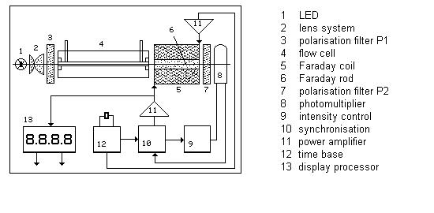

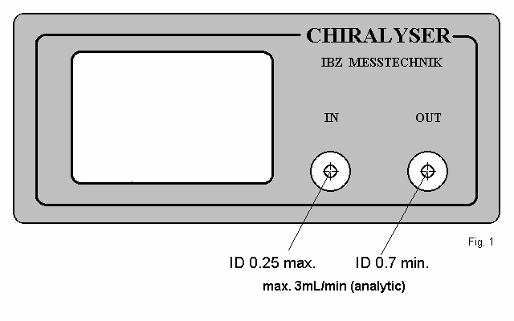

2. Installation

Place the CHIRALYSER nearby to the outlet of the column or to
the outlet of any detector on a solid and vibration-free location.
There must be no other objects placed upon the instrument.

Connect the IN port with a 1/16" capillar with an inner diameter
of 0.25 mm (or less) and suitable fitting to the outlet of the column
or the outlet of a previous detector.

Connect the OUT port with a 1/16” capillar with an inner diameter
of 0.7 mm (or more) and suitable fitting to the system waste.
The CHIRALYSER has to be always the last detector connected
to the HPLC system because of it`s sensitivity to back pressure
caused by other detectors.
Disregard will have high risc for braking the thin glass windows
of the flow cell.

Attention:
There must be no back pressure at the OUT port.
No else detectors may connect to the OUT port.

Only use degassed mobile phase and do not exceed
maximum flow rate ( 3 ml/ min for analytical cell).

2.1 Electrical connections

Mains

Make sure that your ac mains voltage is identical to the value printed
on the identification label at the back side of the instrument.
Operation without proper ground connection is dangerous and will cause
malefunction of the instrument.

Analog Interface and AUTOZERO

Connect the analog cable to your system`s A/D converter input port or
to an Integrator or Chart Recorder. Notice the polarity marked on the cable.
The output voltage range of the CHIRALYSER is 1000 mV related to the
selected baseline offset and measuring range.
Default setting is 500 mV.

The analog cable also carries the signal for the AUTOZERO contact.
Contact has to been closed for minimum 0.5 sec to create ZERO in
the display. There must be no external potential (voltage) at the
contact.
IMPORTANT : Use only original analog cable attached to the consignment.
See section 8.0

Serial Interface

Connect the serial cable to your system`s RS232c input port.
Configurate your system`s serial input port to:

9800 baud, 8 data,1 stop, 1 start, no parity.

The actual measuring value is obtained by sending “?” (ASCII 63)
to the CHIRALYSER.
IMPORTANT : Use only original serial cable attached to the consignment.
For full remote control via serial interface see section 8.1

USB Interface (optional )

Connect the USB adapter to the serial interface connector and to your
system`s USB port . Start the driver CD and follow the instructions
given by the installation program.

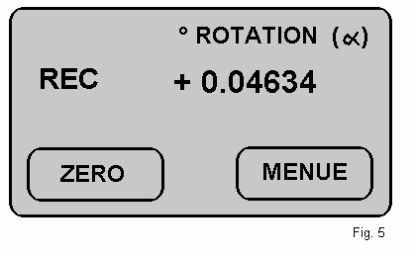
Analog interface overrange. Touch ZERO

Peak detection, see section 3.1

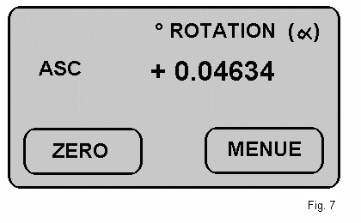
Automatic Symmetry Calibration, see section 4.5

3.0 Start of measurement

After switching POWER on, the CHIRALYSER displays

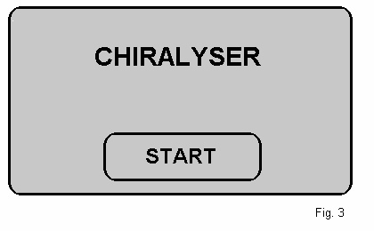
Wait until flow and pressure is balanced and stable and then
touch START.

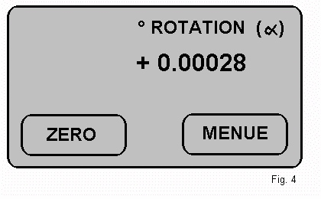
Flashing α indicates correct data sampling.
CHIRALYSER is ready for measuring.
Touch ZERO to start operation in the default mode.

Display may show some additional information.

( see Fig. 5 – 7, left side ).

  - Peak detection

An optically active compound is indicated by peak in the display.
Baseline drift and noise, specially during warm up (approx.30 min.),
will also be indicated by peak.

Increase time constant (AVR) if baseline noise and drift
- under balanced conditions - will indicate permanently PEAK
at the display.

See section 4.0

4.0 Change instrument settings

Touch MENUE for changing the instrument settings

CHIRALYSER will display

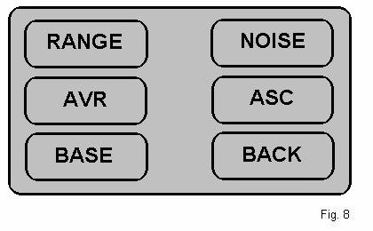

Select parameters to change settings.
Touch BACK to go back to the measuring mode.

4.1 RANGE

Default setting for the measuring range is 8.0 mdeg. / 1000 mV full scale.
Range limits are 4.0 mdeg. / 1000 mV for highest sensitivity and
512.0 mdeg. / 1000 mV for lowest sensitivity.

Select appropriate RANGE by touching the arrow keys.
Touch OK to go back to the measuring mode.

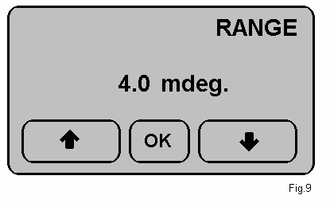

  - AVR (time constant)

Default setting for the AVR time constant is “OFF” (no time constant).
In this setting baseline noise is visible, but lowest limit of detection
is attainable.
AVR settings can be changed within 0.2 sec (fast response) to 3.6 sec
(slow response).
The AVR settings may affect baseline noise and peak geometry.

Select appropriate AVR by touching the arrow keys.
Touch OK to go back to the measuring mode.

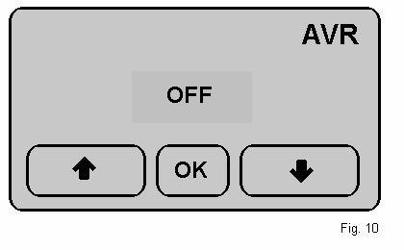

4.3 BASE

Default setting for the baseline offset is 500.0 mV.
Baseline offset limits are 20.0 and 980.0 mV.
Use default setting for symmetrically measuring range.

Select appropriate BASE by touching the arrow keys.
Touch OK to go back to the measuring mode.

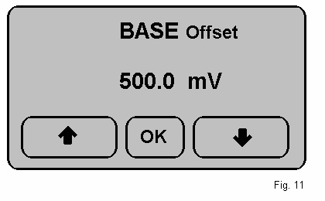

  - NOISE

The displayed noise value effects the dynamic discrimination

level of the AVR settings. Readings are only for diagnostic

purposes and cannot be changed by user.

Touch OK to go back to the measuring mode.

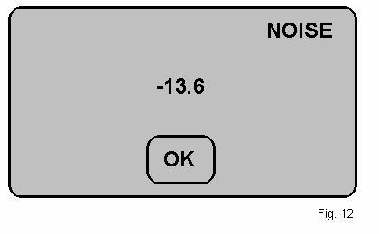

  - ASC ( Automatic Symmetry Calibration )

Internal optical offset, caused by high refractive index of the mobile
phase or mechanical stress to the cell windows will display flashing
ASC in the operational mode (Fig. 7).
Touch MENUE (Fig. 8) and then ASC to start the
Automatic Symmetry Calibration.

CHIRALYSER will display

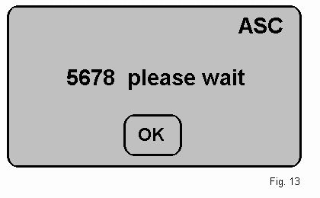

When terminated, CHIRALYSER will display

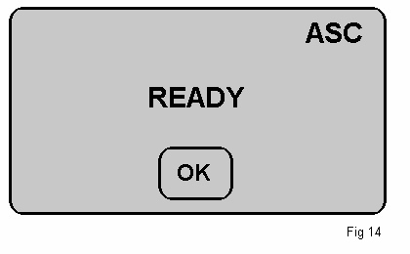
Touch OK to go back to the measuring mode.

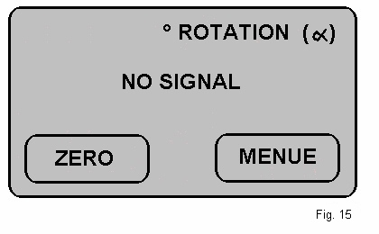

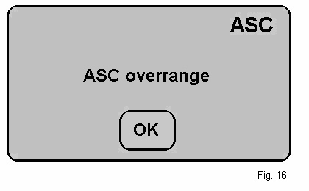

5.0 Troubleshooting

Error message NO SIGNAL
Meaning Air bubbles inside flow cell.
Windows unclean or broken.

Remedy Use only degassed mobile phase.
Raise flow temporary to max. 3 ml/min.
Purge with isopropanol to remove bubbles.
Clean or replace windows. ( see section 6.1)

Error message ASC OVERRANGE
Meaning Internal optical offset is too high,
Automatic Symmetry Calibration cannot
Correct the optical offset.

Remedy Adjust optical balance ( see section 6.1)

Error message Display indicates PEAK at baseline
Operation.
Meaning Baseline is noisy.
Small air bubbles inside flow cell.
Instrument not yet thermically balanced.
Incompatible mobile phase
( e.g.: organic / water).

Remedy Wait until instrument is balanced.
Inject isopropanol to remove bubbles.
Use compatible degassed mobile phase.

Error message Baseline drift
Meaning Instrument not yet thermically balanced

Remedy Wait until instrument is balanced.
Keep temperature constant.

6.0 Service instructions

This chapter contains some easy to do service instructions.
The CHIRALYSER supports the user with diagnostic help.

Opening of enclosures or removing covers may expose live parts.
Connection points may also be live !
If it becomes necessary to work on the apparatus whilst it is
open, this must only be carried out by a skilled person, who is
familiar with the dangers involved.

See: Notes and warnings at the beginning of this manual.

For the following service instructions, the enclosure has to be open.
Switch off power and open / remove the screws according this drawing.
Bend backplane slightly and lift off the upper part of the enclosure.

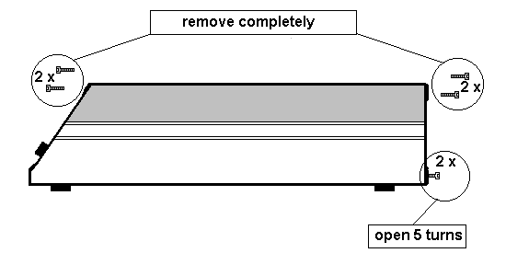

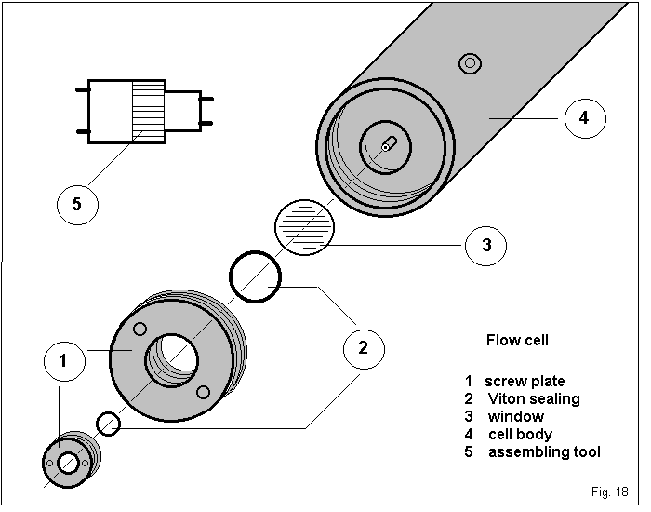

6.1 Disassembling the flow cell

The flow cell must be disassembled if the windows are broken or
require cleaning.
For do so, follow these instructions:

- Switch off power and open the enclosure according the drawing
in section 6.0
- Disconnect the 1/16" fittings at the flow cell (4).
- Remove the cell holder (clamp); take the flow cell to a clean
place for disassembly.
- Open the flow cell by unscrewing the screw plate (1) with the
assembly tool (5).
- Replace the defective or unclean window together with its VITON
seal (2) The area around and under the window must be absolutely
clean; wipe away any particle very carefully.
- Carefully screw the flow cell closed with the assembly tool with very
light torque.
- Repeat the same procedure with the other side of the flow cell.
- Very carefully, tighten both sides – slowly with little torque.
If a screw plate is tightened too quickly, or with too much torque,
stress may be induced to the windows, causing baseline drift.
- Fix the cell with the cell holder (clamp) and reconnect the 1/16“ fittings
to the flow cell.
- close the enclosure and fix screws.

Switch the instrument on and touch START.

Expect some drift for some time, until stress is distributed
in the mechanical / optical system and the instrument gets
balanced.

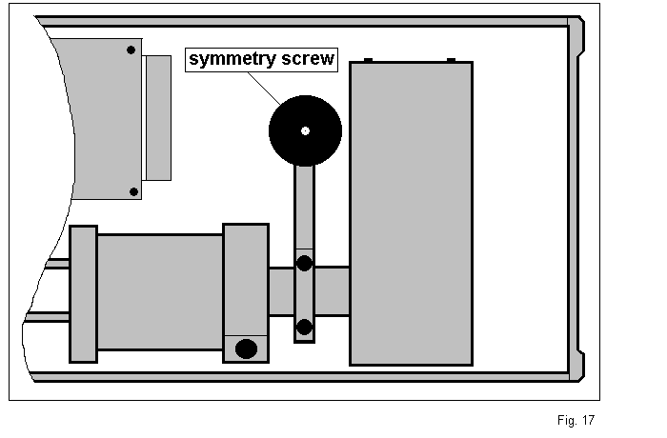

6.2 Mechanical Adjustment of the optical balance

The CHIRALYSER is factory set to an symmetrically measuring range
with excellent optical balance.
This balance may be upset through flow cell disassembly or mechanical
shock by transport and may cause peak cut off and internal optical offset.
This internal optical offset is indicated by displaying a flashing ASC in the
operational mode.
Starting the ASC routine (see section 4.5), will cancel the optical offset.

In case of excessive optical offset, indicated by ASC overrange (see Fig. 16),
the Automatic Symmetry Calibration cannot cancel the optical offset
completely and needs mechanical adjustment of the optical balance.

During the mechanical adjustment, power is on and flow rate should be
1 ml/min.

Do not touch any electronic device nor the printboard inside
the instrument. There is a high risk of electric shock.

Open the enclosure according the drawing in section 6.0
Mark the position of the symmetry screw with a soft pencil.
Slowly rotate the symmetry screw ( Fig. 17) clockwise until display
indicates “please wait” (Fig. 13).
Do not rotate more than 5 turns clockwise. If there is no result, rotate
anti-clockwise for maximum 10 turns.
Close enclosure and continue operation.



7.0 Preparative Cell

This CHIRALYSER is optionally provided with a preparative measuring cell
with an optical length of 100 mm, volume 300 µl.

Recommended flow rate is 5 to 100 ml/minute.
Do not exceed 30 bar (450 psi) pressure at the outlet (OUT) port
and use only degassed mobile phase specially when flow rate is low.

The detector may be much too sensitive in its default settings.
To reduce sensitivity, first make an ASC (Automatic Symmetry Calibration)
with suitable flow according section 4.5 in this manual and then select
appropriate RANGE setting.

If sensitivity is too high even in the highest RANGE setting (512.0 mdeg.),
a shorter measuring cell is recommended.

Installation

The 100 mm cell is placed towards the light source and the “IN”
tubings must be changed to 1/16” with inner diameter 1.0 mm to
minimize backpressure to the column.
Fix clamp midside of the cell.

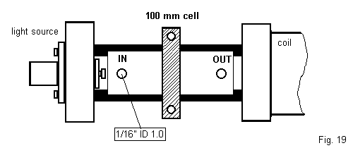

8.0 Pin connections

The Analog cable carries the signal (1000 mV) for the external A/D converter
and the connection for the AUTOZERO contact.

Analog cable ( 5 pole connector male / open )

Pin meaning color

1 Signal Ground green
2 Auozero - close contact to pin 1 - grey
3
4 analog signal negative potential white
5 analog signal positive potential blue

Serial interface cable ( 9 pole D-sub connector male / female )

Pin CHIRALYSER (female)

1 DCD
2 TxD (transmit data)
3 RxD (receive data )
4 DTR
5 GND (signal ground)
6 DSR
7 RTS
8 CTS
9 n.c.

  - Remote control via serial interface

Remote control is given by sending ASCII code to CHIRALYSER according schedule

FORMAT 9800 / 8 / 1 / 1

ASCII mode action

65 (A) START start CHIRALYSER
66 (B) ZERO set display ZERO
87 (W) DISPLAY display off
75 (K) DISPLAY display on

63 (?) REQUEST DATA send measuring data to host

67 (C) MENUE enable MENUE for all settings
73 (I) MENUE back to measuring mode

68 (D) RANGE enable RANGE settings
76 (L) RANGE increase RANGE
77 (M) RANGE decrease RANGE
78 (N) RANGE back to measuring mode

70 (F) AVR enable AVR settings
82 (R) AVR increase AVR
83 (S) AVR decrease AVR
84 (T) AVR back to measuring mode

72 (H) BASE enable BASE settings
79 (O) BASE increase BASE
80 (P) BASE decrease BASE
81 (Q) BASE back to measuring mode

69 (E) HV enable HV
85 (U) HV back to measuring mode

71 (G) ASC enable ASC
86 (V) ASC back to measuring mode

